

Next Generation On Demand (NGOD 2.0)

Session & Edge Resource Interface - S6

January 2006

Document Status Sheet
Document Title: | Session & Edge Resource Interface - S6
Revision History: | ECR # 2 – 3/09/05 – Fix sample SETUP messages to match the RTSP Usage Guide and Development Guidelines. Remove references to TSIDs and replace them with QAM Names.  ECR # 21 – 3/09/05 – Add reference to InBandMarker extension header in setup message from SM.  ECR# 58 – 4/11/05 – Added indents to continuation lines of RTSP header fields  ECR# 59 – 4/11/05 – Modified Require: headers to use com.comcast.ngod.xx  ECR# 61 – 4/11/05 – Added Reason Text to Reason: header examples  ECR # 65 – 4/7/05 – Change reference numbers for Normative and Informative References (Section 2.1 and 2.2) to include respective N and I.  ECR# 95 - 6/2/05 - Added Session Groups to the table of parameters used by S6 in the GET / SET PARAMETER messages.  5/25/05 – Pre-Release 1.1 comments:  - Included the client field in the Transport header.  - Fixed the example to include the qam_name and qam_group in the Setup message sent from the ERM to SM.  - Added the new header, such as annex, into the example.  - Checked to ensure consistency with Implementation Guidelines.  6/2/05 - Complete ECR 58 to make indentation on all messages consistent.  ECR# 131 – 11/28/05 – Added ANNOUNCE code and teardown reason code for a session timeout.  ECR# 180 – 12/13/05 – Added encryption requirements headers to SETUP messages  ECR # 159 – 12/15/05 – Add edge_input_group to the RTSP Transport header on a SETUP response. Add RTSP Teardown reason code 409 “Network Resource Failure”.  ECR #186 - 12/20/05 - Added new response codes and teardown reason codes.
Date: | January 2006
Status: | Work in Progress | Draft | Issued | Released
Distribution Restrictions: | VE Authors Only | VE & PE members only | Suppliers | None
Key to Document Status Codes:
Work in Progress (W) | An incomplete document, designed to guide discussion and generate feedback that may include several alternative requirements for consideration.
Draft (D) | A document in specification format considered largely complete, but lacking review by other VE and PE vendors. Drafts are susceptible to substantial change during the review process.
Issued (I) | A stable document, which has undergone rigorous VE & PE vendor review and is suitable for product design and development, cross-vendor interoperability, and for certification testing.
Released (R) | A stable document, reviewed, tested and validated, suitable to enable cross-vendor interoperability.
Contents
1 Scope 6
1.1 Introduction and Overview 6
1.2 Requirements (Conformance Notation) 6
2 References 8
2.1 Normative References 8
2.2 Informative References 8
3 Terms and Definitions 8
4 Abbreviations and acronyms 8
5 Edge Session Establishment (S6) interface specification 9
5.1 Key Decision Drivers, Scope, and Constraints 9
5.2 Interface Requirements Phasing 10
5.3 Overall Architecture 10
5.3.1 S6 Interaction with Hub & Spoke Architecture 13
5.3.1.1 Pessimistic Resource Allocation 13
5.3.1.2 Optimistic Resource Allocation 16
5.4 Example Signaling Flows 17
5.4.1 Session Initiation (Hub & Spoke Pessimistic Resource Allocation) 17
5.4.2 Session Initiation (Hub & Spoke Optimistic Resource Allocation) 21
5.4.3 Session Tear Down 23
5.4.4 ANNOUNCE from ERM to SM 24
Appendix I. RTSP Message Codes applicable to interface S6 25
I.1 RTSP Setup Response Codes 25
I.2 RTSP Teardown Reason Codes 26
I.3 RTSP Announce Codes 27
I.4 RTSP parameters (Get / Set_Parameter) 27
Appendix II. Threaded Model 29

List of Figures
Figure 1 : Resource Commit Sequence 12
Figure 2: Interface S6 with Pessimistic Resource Allocation 14
Figure 3: Interface S6 with Optimistic Resource Allocation 17
Figure 4: Interface S6 in the threaded architecture 30

List of Tables
Table 1 - Abbreviations and Acronyms 8
Table 2 - RTSP response codes applicable to interface S6 25
Table 3 - RTSP reason codes applicable to interface S6 26
Table 4 - RTSP announce codes applicable to interface S6 27
Table 5 - RTSP parameters applicable to interface S6 28

Scope
This document specifies the protocol (RTSP) as well the protocol extensions to be used for interface S6 between the Session Manager and the Edge Resource Manager.

Introduction and Overview
The Next Generation On Demand Architecture has settled on RTSP as the resource management interface between the Session Manager and resource managers. This document describes the use of RTSP as the protocol used to implement interface S6.
The terminology, message syntax, method definitions, and state machine definitions of RFC 2326 are adhered to in this specification. This specification will refer to the “NGOD Unified RTSP specification” which defines additional status code and header field definitions to enable the specification of HFC based transport parameters and HFC related errors in RTSP.
An Edge Resource Manager that implements interface S6 as specified in this document will be able to support both the SRM hub & spoke and threaded architectures. In the hub & spoke architecture, two forms of resource signaling are supported by the Edge Resource Manager. The first form of resource signaling supports pessimistic resource allocation algorithms in the Session Manager while the second form of signaling supports optimistic resource allocation algorithms.
The threaded architecture supports an optimized version of the pessimistic resource allocation algorithm. A signaling request for pessimistic resource allocation looks identical to a resource manager independent of whether the hub & spoke or threaded architectures are used. Because of this, resource managers work the same independent of whether the hub & spoke or threaded architectures are used for resource allocation signaling.
This document will describe how the ERM operates for both pessimistic and optimistic resource allocation algorithms. This document focuses on the hub and spoke architecture, while providing although it does provide some details about the threaded architecture in Appendix II. Additional details of the threaded architecture are described in the contribution “SRM Architecture – Threaded Model”.

Requirements (Conformance Notation)
Throughout this document, the words that are used to define the significance of particular requirements are capitalized. These words are:
“MUST” | This word or the adjective “REQUIRED” means that the item is an absolute requirement of this specification. The word “MANDATORY” may be used in lieu of “MUST” in certain circumstances.
“MUST NOT” | This phrase means that the item is an absolute prohibition of this specification.
“SHOULD” | This word or the adjective “RECOMMENDED” means that there may exist valid reasons in particular circumstances to ignore this item, but the full implications should be understood and the case carefully weighed before choosing a different course.
“SHOULD NOT” | This phrase means that there may exist valid reasons in particular circumstances when the listed behavior is acceptable or even useful, but the full implications should be understood and the case carefully weighed before implementing any behavior described with this label.
“MAY” | This word or the adjective “OPTIONAL” means that this item is truly optional. One vendor may choose to include the item because a particular marketplace requires it or because it enhances the product, for example; another vendor may omit the same item.

References

Normative References
[N-1] H. Schulzrinne; et al, Real Time Streaming Protocol (RTSP), RFC 2326, April 1998
[N-2] R. Fielding; et al, Hypertext Transfer Protocol -- HTTP/1.1, RFC 2068, January 1997
[N-3] Berners-Lee, T., and D. Connolly, "HyperText Markup Language Specification - 2.0", RFC 1866, November 1995
[N-4] M. Handley; et al, SDP: Session Description Protocol, RFC 2327, April 1998

Informative References
N/A

Terms and Definitions
This specification defines the following terms:

Abbreviations and acronyms
This specification uses the following abbreviations and acronyms:

Table 1 - Abbreviations and Acronyms
ERM | Edge Resource Manager
HFC | Hybrid Fiber Coaxial
MPEG | Motion Picture Experts Group
NGOD | Next Generation On Demand
QAM | Quadrature Amplitude Modulation
RTSP | Real Time Streaming Protocol
SM | Session Manager
SRM | Session Resource Manager
UDP | Universal Datagram Protocol
URL | Universal Resource Locator

Edge Session Establishment (S6) interface specification

Key Decision Drivers, Scope, and Constraints
The Edge Session Establishment (S6) interface was designed with the following goals in mind.
- Leverage and Conform to Existing Protocol Specifications
The Edge Session Establishment (S6) interface should be based on existing protocols if possible. To ensure standards based interoperability, the interface should conform to the requirements of the protocol specification it is based on.
This document describes the use of RTSP as the Edge Session Establishment (S6) interface. The terminology, message syntax, method definitions, and state machine definitions of RFC 2326 are adhered to in this specification. This specification will define additional status code and header field definitions to enable the specification of HFC based transport parameters and HFC related errors in RTSP. To ensure interoperability between vendors, this document will also include a profile for RTSP usage with interface S6.
- Support HFC based resource specifications compatible with interface S1
It should be straight forward to translate the allocated resources specified in interface S6 into a set of tuning parameters to be sent to the On Demand Client via interface S1.
This document defines the syntax for a set of RTSP header fields to specify HFC parameters such as MPEG Program Number, Modulation Frequency, etc. The intent is to make these fields identical to the RTSP header fields specified for the RTSP version of interface S1 and easily translatable to the RTSP header fields specified in the DSM-CC version of interface S1.
- Support both Hub & Spoke and Threaded Architectures
An Edge Resource Manager that supports interface S6 should be able to support both the hub & spoke and threaded architectures without any model specific operating modes or configuration.
An Edge Resource Manager that implements interface S6 as specified in this document will be able to support both the SRM hub & spoke and threaded architectures. When an Edge Resource Manager receives a resource request via interface S6 from a Session Manager implementing the hub & spoke architecture, the Session Manager will specify its IP address as the RTSP Server address in the RTSP URL of the RTSP Setup message.
When an Edge Resource Manager receives a resource request via interface S6 from a Session Manager implementing the threaded architecture, the Session Manager will specify the IP address of the On Demand Resource Manager as the RTSP Server address in the RTSP URL of the RTSP Setup message. If the RTSP header field and status code definitions specified by both this document and interface S3 are consistent, then an RTSP message forwarded from the Edge Resource Manager to the On Demand Resource Manager should cause no interoperability issues between those components.
- Support both Optimistic and Pessimistic Routing
In the Optimistic Routing Model, the Session Manager specifies the Edge Resource Manager address in the RTSP URL. This indicates that the Edge Resource Manager acts as the server and returns its resource selections to the Session Manager.
For Pessimistic Routing, the Session Manager specifies a different address in the RTSP URL. This indicates that the Edge Resource Manager acts as a proxy, forwarding the RTSP request to the specified server with the resource selection. The RTSP server confirms the resource selection and returns a response to the Edge Resource Manager, which then returns that result to the Session Manager.

Interface Requirements Phasing
A future version of this specification will include a profile for interface S6 to be used between the Session Manager and a new component called the Edge Resource Manager Router. This profile will specify a subset of the messages and features of the Edge Session Establishment (S6) interface specified in this document.

Overall Architecture
Using interface S6, Edge Resource Managers support resource requests from Session Managers that support the hub & spoke signaling architecture as well as the threaded signaling architecture. Edge Resource Managers must support both the pessimistic and optimistic resource allocation models using interface S6. The hub & spoke signaling architecture supports both pessimistic and optimistic resource allocation models while the threaded architecture supports an optimized version of the pessimistic resource allocation model. Because the signaling for pessimistic resource allocation looks the same to an Edge Resource Manager independent of which signaling model is used, Edge Resource Managers that support interface S6 will support both the hub & spoke and threaded signaling architectures transparently.
A pessimistic resource allocation algorithm is one where the Session Manager obtains a list of potential resources from each resource manager and then selects the optimal set of resources based on the available resource returned by each resource manager. With a pessimistic resource allocation model, each resource manager implements a reserve / commit process for resource allocation. The resource manager reserves a set of resources that may be used for the session and returns the list of those resources to the Session Manager. When the Session Manager picks a particular resource to use for the session, the resource manager commits that resource and frees the others for use in other resource requests.
In an optimistic resource allocation algorithm, the Session Manager asks for a single resource from each resource manager. The session manager may use heuristics from knowledge of previous sessions (such as recently released resources) to request a specific resource from each resource manager. If the Session Manager finds that a network path does not exist between the selected resources, the Session Manager will release one or more of the resources and retry the resource allocation sequence. The optimistic model works best when there is full connectivity between the edge devices and streaming servers that feed a specific service group.
Resource managers that receive a resource request from a Session Manager using an optimistic resource allocation algorithm implement a single stage resource allocation algorithm. Upon receiving a resource request from the Session Manager the resource manager will commit a resource from its resource pool that matches the resource requirements specified in the resource request. If the Session Manager finds that the resource returned from a resource manager does not work with the resources returned from other resource managers, it will release that resource and request another one from the resource manager. The hub & spoke architecture specification describes how the Session Manager operates using both pessimistic and optimistic resource allocation algorithms.
Since RTSP is used to implement interface S6, standard RTSP roles will apply to both the Session Manager and the Edge Resource Manager. The Session Manager will appear as an RTSP client and the Edge Resource Manager will appear as either an RTSP proxy or an RTSP server depending on whether the pessimistic or optimistic resource allocation models are used, respectively.
The On Demand Client transmits On Demand Session requests to the Session Manager using interface S1. To allocate resources for the session request using either a pessimistic or optimistic resource allocation algorithm, the Session Manager will send an RTSP Setup Message to the Edge Resource Manager. After allocating Edge resources for the session, the Edge Resource Manager must return both IP and RF information to the Session Manager. The IP information specifies the IP address / UDP port number destination of the MPEG SPTS transmitted by the Streaming Server. The RF information specifies the MPEG program number and Modulation frequency that should be used by the STB to receive the video stream.
A Session Manager that makes a resource request using S6 in the hub & spoke architecture will specify either its own IP address or the IP address of the Edge Resource Manager as the RTSP Server address in the RTSP URL of the RTSP Setup message. The Session Manager will specify itself as the RTSP server in the RTSP URL if it is using pessimistic resource allocation while it will specify the Edge Resource Manager as the RTSP server in the RTSP URL if it is using optimistic resource allocation. A Session Manager that makes a resource request using S6 in the threaded architecture will specify the IP address of a resource manager (the On Demand Resource Manager) as the RTSP Server address in the RTSP URL of the RTSP Setup message.
When an Edge Resource Manager receives a resource request via interface S6 from a Session Manager it will operate as either an RTSP Proxy or an RTSP Server, depending upon the RTSP URL specified in the SETUP message.
If the Session Manager specifies an IP address different than that of the Edge Resource Manager in RTSP URL of a Setup message, the Edge Resource Manager will act as an RTSP proxy and forward RTSP messages to the RTSP Server specified in the URL. When an Edge Resource Manager acts as an RTSP proxy in the resource signaling flow, it will implement a 2 stage reserve / commit process for resource allocation. One pair of RTSP messages will be used to implement the reserve stage while another pair will be used to implement the commit stage. The 2 stage reserve / commit process is used with pessimistic resource allocation algorithms.
If the Session Manager specifies the IP address of the Edge Resource Manager in RTSP URL of a Setup message, the Edge Resource Manager will act as an RTSP server. When an Edge Resource Manager acts as an RTSP server in the resource signaling flow, it will implement a single stage commit process for resource allocation. This single state commit process will use one pair (Setup, Set Response) of RTSP messages to commit the resource required for the session. The single stage commit process is used with optimistic resource allocation algorithms.
The diagram below shows the resource commit sequence for both the optimistic and pessimistic models.

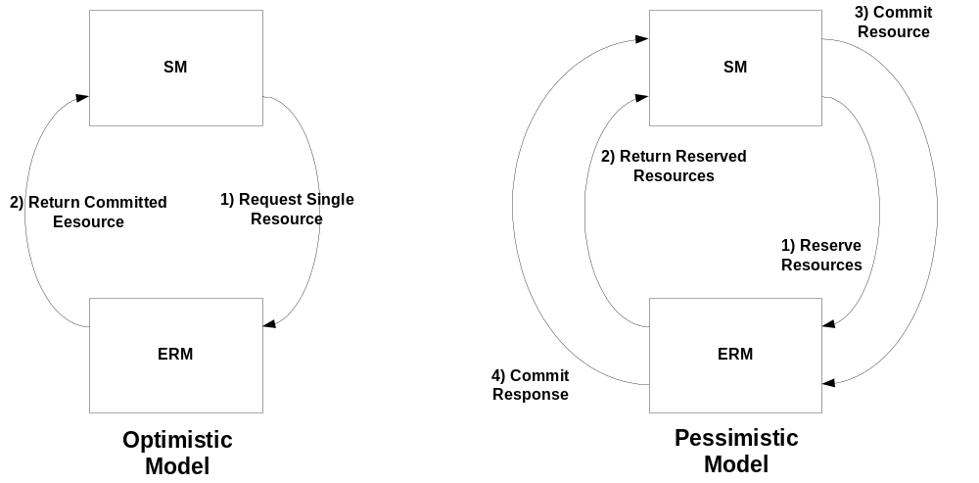

Figure 1 : Resource Commit Sequence

When an Edge Resource Manager receives a resource request via interface S6 from a Session Manager implementing the threaded architecture, the Session Manager will specify the IP address of the On Demand Resource Manager as the RTSP Server address in the RTSP URL of the RTSP Setup message. The Edge Resource Manager will handle this request as a pessimistic resource allocation request and proceed with the 2 stage reserve / commit process between itself and the On Demand Resource Manager. Since the RTSP header field and status code definitions are consistent across all resource allocation (Sx) interfaces, an RTSP message forwarded from the Edge Resource Manager to the On Demand Resource Manager should cause no interoperability issues between those components.
Section 12.39 of RFC 2326 specifies a header field called the Transport header. The Transport header specifies the parameters associated with the transport of the media stream from the RTSP Server to the RTSP client. Since Edge Devices (QAMs) are essentially media gateways and pass the MPEG transport stream through them, they have two RTSP Transport header specifications associated with them. One Transport header will be used to describe the IP transport parameters (IP address / UDP port number) of the MPEG/UDP SPTS media stream (V3) from the Streaming Server to the Edge Device. The other Transport header will be used to describe the HFC transport parameters (MPEG Program # / Modulation Frequency) of the MPEG MPTS media stream (V4) from the Edge Device to the Set Top Box.
When the Edge Resource Manager acts as an RTSP proxy in the resource allocation signaling flow, it will end up with one RTSP session between itself and the Session Manager and another between itself and node specified as the RTSP Server in the RTSP URL. The RTSP session between the Edge Resource Manager and the Session Manager will be used to specify the transport parameters of the RF modulated (V4) media stream while the RTSP session between the Edge Resource Manager and the specified RTSP Server will be used to specify the IP transport parameters of the MPEG/UDP (V3) media stream.
When the Edge Resource Manager acts as an RTSP server in the resource allocation signaling flow, there will be a single RTSP session between the Edge Resource Manager and the Session Manager. Because RFC 2326 only allows a single transport header to be specified by an RTSP server, the Edge Resource Manager will return a single RTSP Transport header to specify the transport parameters for both the RF modulated (V4) media stream and the MPEG/UDP (V3) media stream.

S6 Interaction with Hub & Spoke Architecture
This section describes how S6 is used to interface between the Edge Resource Manager and the Session Manager for both pessimistic and optimistic resource allocation algorithms.

Pessimistic Resource Allocation
Figure 2 illustrates the RTSP session model and message sequence used for interface S6 when pessimistic resource allocation is used in the hub & spoke architecture. Interface S6 actually consists of two separate RTSP sessions between the Session Manager and Edge Resource Manager. One session is used to exchange HFC transport information between the ERM and SM. The other session is used to exchange IP transport information. These 2 RTSP sessions are tied together using session logic in both the ERM and SM. The ERM appears as an RTSP proxy in the signaling model. The ERM appears as an RTSP Server in the RTSP session used to exchange HFC transport information and an RTSP client in the RTSP session used to exchange IP transport information. The ERM ties the RTSP client and server state machines together using standard proxy mechanisms. The SM ties the two RTSP sessions together using an RTSP parameter that specifies On Demand Client session these sessions are associated with. Both RTSP sessions will have the same value of this On Demand session parameter. Note that interface S6 uses the persistent transport option connections as described in section 9 of RFC 2326. Because of this, both RTSP sessions can be carried over the same TCP/IP session between the Session Manager and Edge Resource Manager.
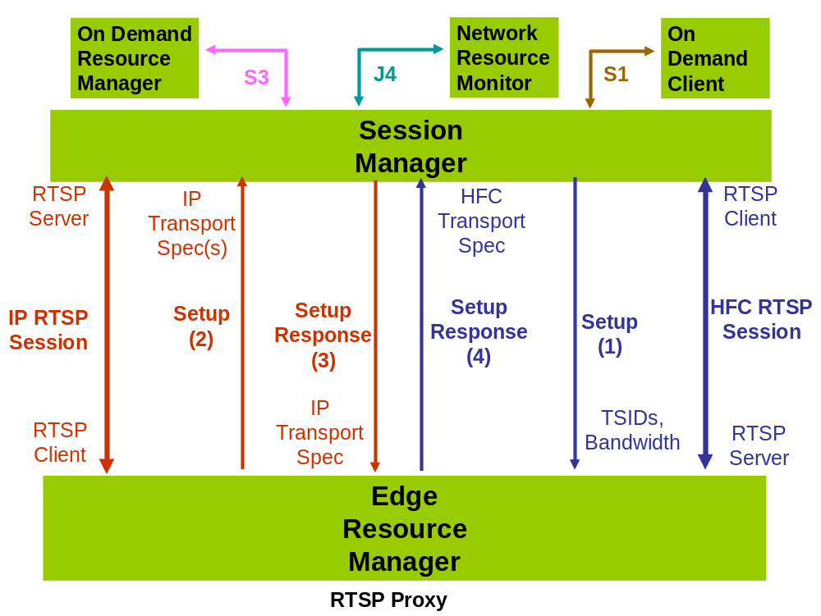

Figure 2: Interface S6 with Pessimistic Resource Allocation

The message sequence illustrated in Figure 2 shows how the two RTSP sessions are related to each other. The Session Manager starts the message sequence by sending an RTSP Setup(1) message to the Edge Resource Manager. This message includes the set of QAM Names that were specified by the On Demand Client via interface S1 as well as the bandwidth required for the session. The message also includes an RTSP URL. As specified in section 3.2 of RFC 2326, the RTSP URL includes the hostname of the RTSP server that the message is intended for as well as a path specification which is interpreted by the host specified in the URL. The RTSP Setup message sent by the Session Manager will specify itself as the RTSP Server in hostname field of the RTSP URL. The abs-path field of the RTSP URL should match what is specified in the registration advertisement sent from the Edge Resource Manager to the Edge Resource Manager Router via interface D2. Section 5.4.1.1 of the SRM Service Discovery and Registration specification defines the syntax of the abs-path field that is sent by an Edge Resource Manager using interface D2.
When the Edge Resource Manager receives the initial Setup message, it uses the QAM Names to determine which Edge Device(s) to allocate resources from. The ERM then selects one or more Edge Devices that may be used to satisfy this request based on the requested bandwidth and other parameters in the Setup request. If the ERM selects more than one Edge Device for a particular resource request, each Edge Device that is selected should be attached to the IP network at a different point (connected to a different IP subnet). Once the ERM has selected the Edge Device(s) to be used for the session, it reserves the resources for those Edge Devices and communicates their IP transport parameters to the RTSP server indicated in the RTSP URL. The ERM examines the hostname of the RTSP URL to determine that it does not point to itself. It does this by comparing the IP address associated with the hostname field to its own IP address. When pessimistic resource allocation algorithms are used, the IP address indicated by the hostname field will always be different than the ERM’s address, so the ERM will forward a modified version of the RTSP Setup(2) message to the host indicated in the RTSP URL (the Session Manager). This RTSP Setup message will include the IP Transport spec(s) for each of the Edge Device(s) selected/reserved for the session.
When the Session Manager receives the Setup(2) message back from the ERM, it correlates it to the original RTSP session request it launched previously by comparing the On Demand Session parameter to client sessions that are currently active. Note that since the Session Manager determines the format of the path name field of the RTSP URL, the path name field could also be used for this purpose. The Session Manager examines the potential IP Transport specs it received in the Setup message from the ERM along with IP Transport specs obtained from the On Demand Resource Manager via interface S3 to determine a valid IP network path between the potential Streaming Servers and Edge Devices. The Session Manager may use the services of the Network Resource Monitor to determine which Edge Devices can be reached by each of the potential Streaming Servers the ODRM has returned via interface S3. The contribution “Session Resource Management Architecture Threaded Model” provides information on the function of the Network Resource Monitor as well as the protocol used to request information from the Network Resource Monitor. Once the Session Manager selects the Edge Device to be used for the session, it returns the IP Transport spec for this Edge Device in the RTSP Setup Response(3). Note that that IP source address / UDP port number of the Streaming Server selected for the session should also be included in this Transport spec. Source addressing information will allow the Edge Device to provide some level of authentication of the MPEG stream by filtering incoming packets for that stream using the IP source address / UDP port pair associated with that stream.
When the ERM receives the Setup Response(3), it commits the resources for the Edge Device indicated in the IP Transport spec of that message. It then returns the HFC parameters (Tuning Frequency +MPEG Program #) to be used by the Set Top to receive the MPEG stream to the Session Manager in a second Setup Response(4).
When the Session Manager receives the Setup Response(4), it translates the HFC tuning parameters into the parameters to be returned to the Set Top via interface S1. At this point, resource signaling via interface S6 is completed.

Optimistic Resource Allocation
Figure 3 illustrates the RTSP session model and message sequence used for interface S6 when optimistic resource allocation is used in the hub & spoke architecture. In this model, there is a single RTSP session between the Session Manager and the Edge Resource Manager. The Session Manager appears as an RTSP client while the Edge Resource Manager appears as an RTSP Server.
In this model, the Edge Resource Manager commits a single resource and returns a combination IP / HFC Transport header and based on the parameters passed to it in the Setup Request by the Session Manager. The Session Manager passes the QAM Names it received in the On Demand session request from the On Demand client via interface S1 in the S6 Setup request. When the Edge Resource Manager receives the initial Setup message, it uses the QAM Names to determine which Edge Device(s) to allocate resources from. The ERM MUST select resources from a single QAM multiplex to satisfy the request even if there is more than one QAM to choose from.
If the ERM has multiple Edge Devices connected to different subnets to choose from, it will likely not have enough information in the Setup request to select the right Edge Device for that session request. For example, the Edge Device selected by the ERM may not be reachable in the IP transport network by a Streaming Server that has the requested asset. Since the ERM will likely not know the data plane address of the Streaming Server port chosen for the session, it cannot determine which Edge Device to pick for the session request. When this occurs, the Session Manager can determine that the resources selected for the session do not work together by using the services of the Network Resource Monitor. The Session Manager can then try to reallocate the resources for the session by deallocating / reallocated resource from a resource manager.
Note that the Session Manager may include parameters in the Setup request to the ERM other than the requested bandwidth, QAM Names, etc. For example, if the Session Manager already knows which Streaming Server port has been selected for a session, it may pass the source IP address of selected Streaming Server port to the ERM using the Transport header in the Setup message. The ERM could then use the services of the Network Resource Monitor to determine which Edge Device(s) could be used for that session.
Since the Transport header used for optimistic resource allocation includes both IP and HFC transport parameters, it has a different syntax than that specified in the flows documented in section 5.4. The “NGOD Unified RTSP specification” specifies the syntax and semantics of the combined IP / HFC Transport header used for optimistic resource allocation signaling to the Edge Resource Manager.
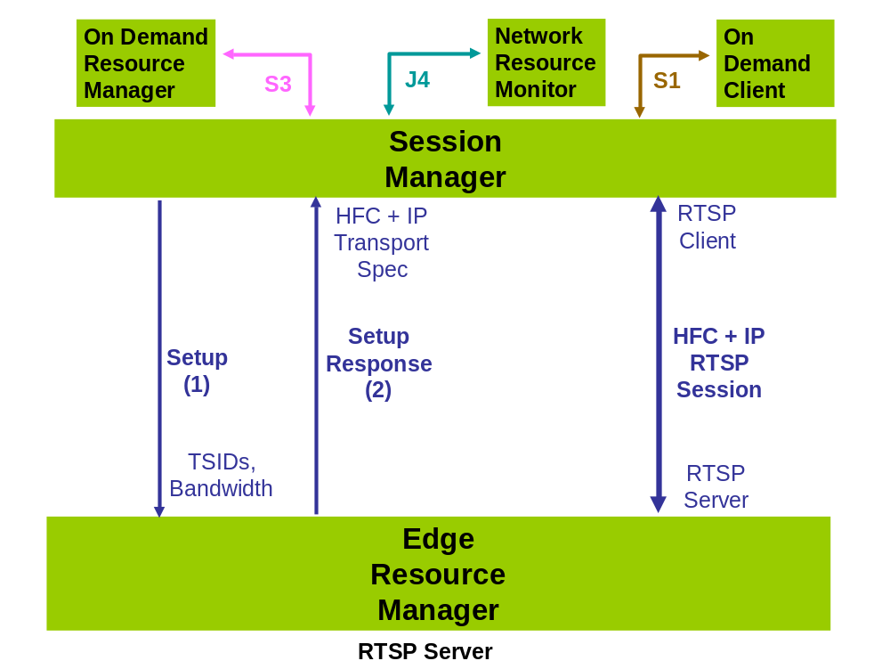

Figure 3: Interface S6 with Optimistic Resource Allocation

Example Signaling Flows
This section provides a description of the RTSP flows described in section 5.3. This section complements the description by providing and describing example RTSP messages used to initiate the session. The syntax / semantics used for the RTSP headers shown in this section were obtained from the “NGOD Unified RTSP specification”.

Session Initiation (Hub & Spoke Pessimistic Resource Allocation)
This section provides a description of the pessimistic resource allocation session setup flow for the hub & spoke architecture described in section 5.3.1.1 and illustrated in Figure 2. The session setup flow for the threaded architecture looks almost identical to the ERM as the flow described in this section. Because of this, this document does not include a separate example signaling flow for the threaded architecture.
The Session Manager starts the message sequence by sending an RTSP Setup(1) message to the Edge Resource Manager. This message includes the set of QAMs that were specified by the On Demand Client via interface S1 as well as the bandwidth required for the session. The text sequence below shows an example of a Setup(1) message sent from the SM to the Edge Resource Manager:

SETUP rtsp://srm1.net RTSP/1.0
CSeq: 313
Require: com.comcast.ngod.s6
SessionGroup: Chicago.SouthBend.SM1
EncryptionType: Session
CAS_ID: 0x1234
EncryptControl: block_stream_until_encrypted=”false”;
encryption_scheme=“AES”;key_length=128
Transport:
MP2T/DVBC/QAM;unicast;bandwidth=2700000;
qam_name=Chicago.SouthBend.5;client=00AF123456DE;
modulation=qam64,
MP2T/DVBC/QAM;unicast;bandwidth=2700000;
qam_name=Chicago.SouthBend.10;client=00AF123456DE;
modulation=qam64,
MP2T/DVBC/QAM;unicast;bandwidth=2700000;
qam_name=Chicago.SouthBend.20;client=00AF123456DE;
modulation=qam64
OnDemandSessionId: be074250-cc5a-11d9-8cd5-0800200c9a66
Policy: priority=1
InbandMarker:type=4;pidType=A;pidValue=01EE;dataType=T;
insertDuration=10000;data=4002003030…

The message above requests that HFC resources for on demand session be074250-cc5a-11d9-8cd5-0800200c9a66 be allocated. 2.7 Mbps of HFC bandwidth must be reserved. The Edge Device will use QAM modulated MPEG-2 transport. RF resources for this request must be allocated from one of the named QAMs. The On Demand session that this resource request is associated with is be074250-cc5a-11d9-8cd5-0800200c9a66. Use of the policy header by the ERM is optional at this time, but its presence must not adversely effect operation of the ERM. The InBandMarker is also not used by the ERM, but must be passed on to the Edge Device when setting up a session on the Edge device using interface R6. The SETUP message also includes the encryption requirements for the stream; it is to be session encrypted using the CAS with ID 0x1234, a scheme of AES and a key length of 128 bits. If any of the listed QAMs have an embedded encryptor that matches these requirements, the EmbeddedEncryptor header will be present in the SETUP response.
When the Edge Resource Manager receives the SETUP message from the SM, it performs RF resource allocation. Using the QAM Names in the SETUP message, it reserves resources on one or more Edge Devices. If the ERM selects more than one Edge Device for a particular resource request, each Edge Device that is selected should be attached to the IP network at a different point (connected to a different IP subnet). Once the ERM has selected the Edge Device(s) to be used for the session, it reserves the resources for those Edge Devices and communicates their IP transport parameters to the RTSP server indicated in the RTSP URL. The host field of the RTSP URL is used to determine where to send the outgoing RTSP Setup message to. The text sequence below shows an example of a Setup(2) message sent from an Edge Resource Manager back to the Session Manager:

SETUP rtsp://srm1.net RTSP/1.0
CSeq: 413
Require: com.comcast.ngod.s6
SessionGroup: Chicago.SouthBend.SM1
Transport:
MP2T/DVBC/UDP;unicast;destination=192.26.13.1;
client_port=4588;client=00AF123456DE,
MP2T/DVBC/UDP;unicast;destination=192.26.14.1;
client_port=4000;client=00AF123456DE
OnDemandSessionId: be074250-cc5a-11d9-8cd5-0800200c9a66
Policy: priority=1

The message above indicates the IP addresses of the Edge Devices that the ERM has reserved for this session. The Session Manager may select an Edge Device at either the IP transport address 192.26.13.1 or 192.26.14.1 for the session. Note that in the Setup(2) message above, the HFC related information in Setup(1) has been replaced with IP Transport information. Since the ERM is an RTSP proxy, all of the other parameters of the RTSP Setup message are passed unchanged.
When the Session Manager receives the Setup(2) message back from the ERM, it correlates it to the original RTSP session request it launched previously by comparing the OnDemandSessionId parameter to On Demand sessions that are currently active. Since the value of the OnDemandSessionId header in Setup(1) is the same as Setup(2), these 2 Setup messages are associated with the same On Demand Client session. The Session Manager examines the potential IP Transport specs it received in the Setup message from the ERM along with IP Transport specs obtained from the On Demand Resource Manager via interface S3 to determine a valid IP network path between the potential Streaming Servers and Edge Devices. Once the Session Manager selects the Edge Device to be used for the session, it returns the IP Transport spec for this Edge Device in the RTSP Setup Response(3). The text sequence below shows an example of a Setup Response(3) message sent from the Session Manager back to the Edge Resource Manager:

RTSP/1.0 200 OK
CSeq: 413
Session: 3500123
Transport:
MP2T/DVBC/UDP;unicast;destination=192.26.14.1;
client_port=4000;source=192.26.18.1;server_port=625;
client=00AF123456DE
EmbeddedEncryptor: Yes
OnDemandSessionId: be074250-cc5a-11d9-8cd5-0800200c9a66

This message includes the IP destination address (192.26.14.1) of the Edge Device that was selected by the Session Manager for the session as well as the source IP address of the Streaming Server (192.26.18.1) that was selected for the session in the Transport header. The OnDemandSessionId Parameter is returned unchanged. The message includes the EmbeddedEncryptor header indicating that the chosen Edge Device has an embedded encryptor that matches the encryption requirements specified in the SETUP message. If the Edge Device does not have an embedded encryptor, the response may omit the EmbeddedEncryptor header, or it may set the value to "No".
When the ERM receives the Setup Response(3), it commits the resources for the Edge Device indicated in the IP Transport spec of that message. It then returns the HFC parameters (Tuning Frequency +MPEG Program #) to be used by the Set Top to receive the MPEG stream to the Session Manager in a second Setup Response(4). The text sequence below shows an example of a SETUP response sent from a Edge Resource Manager to the Session Manager using interface S6:
RTSP/1.0 200 OK
CSeq: 313
Session: 47112344
Transport:
MP2T/DVBC/UDP;unicast;client=00AF123456DE;
destination=192.26.14.1;client_port=4000;
qam_destination=550000000.15;
qam_name=Chicago.SouthBend.5;
qam_group=Chicago.SouthBend.QG001;
edge_input_group=Chicago.SouthBend.S101
EmbeddedEncryptor: Yes
OnDemandSessionId: be074250-cc5a-11d9-8cd5-0800200c9a66

The response above specifies that the Edge Device with IP Address 192.26.14.1 will accept data on port 4000, and will be using MPEG transport over an HFC network. The edge input group identifier of Chicago.SouthBend.S101 is used by the SM to obtain a list of SOP Groups for selecting a string server. The MPEG stream will be modulated at 550 MHz using MPEG program number 15 (destination=550000000.15). Note that the RTSP session ID in RTSP Setup Response(4) is different than the RTSP session ID in RTSP Setup Response(3). Since the ERM may have RTSP sessions with multiple Session Managers, it should allocate its own session IDs to ensure they are unique.

Session Initiation (Hub & Spoke Optimistic Resource Allocation)
This section provides a description of the optimistic resource allocation session setup flow for the hub & spoke architecture described in section 5.3.1.2 and illustrated in Figure 3.
With optimistic resource allocation, the ERM acts as an RTSP server and the Session Manager acts as an RTSP client. Because of this, there is only one RTSP transaction (Setup, Setup Response) between the Session Manager and ERM. The Session Manager specifies a list of possible QAM resources (QAM Names) to the ERM in the RTSP Setup and the ERM returns the RTSP transport spec for a specific QAM resource in the RTSP response.
The Session Manager may restrict the list of resources that the ERM may choose from by restricting the list of potential QAM Names or even specifying a particular set of QAM Name / MPEG program # pairs to the ERM in the Transport header of the RTSP Setup. In the example session flow described in this section, the Session Manager does not restrict the list of potential resources the ERM may choose from in the RTSP Setup message.
The text sequence below shows an example of a Setup(1) message sent from the SM to the Edge Resource Manager:
SETUP rtsp://erm_ip RTSP/1.0
CSeq: 313
Require: com.comcast.ngod.s6
SessionGroup: Chicago.SouthBend.SM1
EncryptionType: Session
CAS_ID: 0x1234
EncryptControl: block_stream_until_encrypted=”false”;
encryption_scheme=“AES”;key_length=128
Transport:
MP2T/DVBC/QAM;unicast;client=00AF123456DE;
bandwidth=2700000;qam_name=Chicago.SouthBend.5;
modulation=qam64,
MP2T/DVBC/QAM;unicast;client=00AF123456DE;
bandwidth=2700000;qam_name=Chicago.SouthBend.10;
modulation=qam64,
MP2T/DVBC/QAM;unicast;client=00AF123456DE;
bandwidth=2700000;qam_name=Chicago.SouthBend.15;
modulation=qam64
OnDemandSessionId: be074250-cc5a-11d9-8cd5-0800200c9a66
Policy: priority=1
InbandMarker:type=4;pidType=A;pidValue=01EE;dataType=T;
insertDuration=10000;data=4002003030…

The message above requests that HFC resources for on demand session be074250-cc5a-11d9-8cd5-0800200c9a66 be allocated. 2.7 Mbps of HFC bandwidth must be reserved. The Edge Device will use QAM modulated MPEG-2 transport. RF resources for this request must be allocated from one of the named QAMs. The On Demand session that this resource request is associated with is be074250-cc5a-11d9-8cd5-0800200c9a66. Note that the hostname field of the RTSP Setup message resolves to the ERM. Because of this, the ERM acts as an RTSP Server (as opposed to an RTSP Proxy) in this signaling transaction. Use of the policy field by the ERM is optional at this time, but its presence must not adversely effect operation of the ERM. The InBandMarker is also not used by the ERM, but must be passed on to the Edge Device when setting up a session on the Edge device using interface R6. The SETUP message also includes the encryption requirements for the stream; it is to be session encrypted using the CAS with ID 0x1234, a scheme of AES and a key length of 128 bits. If any of the listed QAMs have an embedded encryptor that matches these requirements, the EmbeddedEncryptor header will be present in the SETUP response.

When the Edge Resource Manager receives the SETUP message from the SM, it performs RF resource allocation. Using the QAM Names in the SETUP message, it reserves resources on one Edge Device and returns both the IP and UDP transport parameters for the selected QAM in the RTSP response. The text sequence below shows an example of a Setup(2) response message sent from an Edge Resource Manager back to the Session Manager:
RTSP/1.0 200 OK
CSeq: 313
Session: 47112344
Transport:
MP2T/DVBC/UDP;unicast;client=00AF123456DE;
qam_destination=550000000.15;
destination=192.26.13.1;client_port=4588;
qam_name=Chicago.SouthBend.5;
qam_group=Chicago.SouthBend.QG001;modulation=qam64;
edge_input_group=Chicago.SouthBend.S101
EmbeddedEncryptor: Yes
OnDemandSessionId: be074250-cc5a-11d9-8cd5-0800200c9a66

The response above includes a combined MPEG/QAM and IP transport spec for the selected QAM channel. The MPEG/QAM portion of the transport spec specifies that the Edge Device with IP Address 192.26.13.1 will accept data on port 4588, and will be using MPEG transport over an HFC network. The edge input group identifier of Chicago.SouthBend.S101 is used by the SM to obtain a list of SOP Groups for selecting a string server. The MPEG stream will be modulated using QAM64 at 550 MHz using MPEG program number 15 (destination=550000000.15). The IP portion of the transport spec specifies the destination IP address / UDP port pair that should be used for the MPEG/UDP stream to the QAM. The message includes the EmbeddedEncryptor header indicating that the chosen Edge Device has an embedded encryptor that matches the encryption requirements specified in the SETUP message. If the Edge Device does not have an embedded encryptor, the response may omit the EmbeddedEncryptor header, or it may set the value to "No".

Session Tear Down
This section provides a description of a Teardown issued for the RTSP session whose setup flow described in section 5.4.1.
The Session Manager starts the message sequence by sending an RTSP Teardown message to the Edge Resource Manager. This message includes the session ID for the session. The text sequence below shows an example of a Teardown message sent from the SM to the Edge Resource Manager:
TEARDOWN rtsp://srm1.net RTSP/1.0
CSeq: 314
Require: com.comcast.ngod.s6
Reason: 200 “User stop”
Session: 47112344
OnDemandSessionId: be074250-cc5a-11d9-8cd5-0800200c9a66

When the ERM receives the Teardown request, it forwards it back to the SM since its RTSP Server session with the SM (ID=47112344) is tied to its RTSP client session (ID=3500123). The text sequence below shows an example of a Teardown message sent from the ERM back to the SM via the RTSP proxy mechanism:
TEARDOWN rtsp://srm1.net RTSP/1.0
CSeq: 414
Require: com.comcast.ngod.s6
Reason: 200 “User stop”
Session: 3500123
OnDemandSessionId: be074250-cc5a-11d9-8cd5-0800200c9a66

When the SM receives the Teardown request back from the ERM, it free the resources associated with its RTSP Server state machine. It then confirms the Teardown request with a Teardown response:
RTSP/1.0 200 OK
CSeq: 414
Session: 3500123
OnDemandSessionId: be074250-cc5a-11d9-8cd5-0800200c9a66

Upon receiving the Teardown response, the ERM frees all resources associated with session and forwards the Teardown response to the SM:
RTSP/1.0 200 OK
CSeq: 314
Session: 47112344
OnDemandSessionId: be074250-cc5a-11d9-8cd5-0800200c9a66

The SM now frees all resources associated with the RTSP session and considers the Edge Resources allocated to this client session to now be freed.

ANNOUNCE from ERM to SM
Interface S6 supports an asynchronous notification method that the ERM may use to send events to the Session Manager in the context of an existing RTSP session.
An example of where this may be used is when the ERM detects that an Edge Device with active sessions has failed. The ERM may learn of this failure via interface D6 or some other mechanism. Upon learning of the failure, the ERM should send an updated VREP advertisement to the ERMR via interface D2. The ERM should also send error indications to the SM on all active sessions that have been affected by the Edge Device failure. These error indications are sent to the ERM through the RTSP ANNOUNCE method.
The following sequence is an example of the announce message sent from the ERM to the SM to indicate the failure of a video stream due to the failure of a QAM channel.
ANNOUNCE rtsp://srm1.net RTSP/1.0
CSeq: 415
Require: com.comcast.ngod.s6
Session: 47112344
Notice: 5401 “Downstream Failure”
event-date=19930316T064707.735Z npt=
OnDemandSessionId: be074250-cc5a-11d9-8cd5-0800200c9a66

The message above indicates that the video stream associated with the S6 (RTSP) session 47112344 is no longer reaching the Set Top. This is indicated by the Announce code 5401 which indicates a “Downstream Failure”. The Notice header above is an NGOD RTSP header extension. The Notice header includes an announce code “5401”, an announce reason string “Downstream failure”, and the time the message was generated “event-date, npt”. The NGOD common RTSP specification includes more information on the syntax and semantics of the Notice: header. Where npt is not know, it will be left blank.

RTSP/1.0 200 OK
CSeq: 415
Session: 47112344
OnDemandSessionId: be074250-cc5a-11d9-8cd5-0800200c9a66
The response above indicates that the Session Manager accepted the indication from the ERM. Given that the above Announce message sequence specifies a fatal error in an existing MPEG stream, the Session Manager would next send an RTSP teardown request to the ERM similar to the flow illustrated in section 5.4.3.
- RTSP Message Codes applicable to interface S6
This section documents how the RTSP codes specified in the NGOD common RTSP specification are used in interface S6. This section essentially documents the subset of RTSP codes that are applicable to interface S6.
  - RTSP Setup Response Codes
Table 2 below specifies which RTSP reason codes documented in section 10.2 of the NGOD Common RTSP specification are applicable to interface S6. The table includes the meaning of each reason code within the context of interface S6.

Table 2 - RTSP response codes applicable to interface S6
Code | Message | Cisco Application / Meaning
200 | OK | OK
400 | Bad Request | N/A
403 | Forbidden | N/A
404 | Not Found | TSID not found; TSID does not exist on this Edge QAM, or invalid URL
405 | Method Not Allowed | Method Not Allowed. Example = Play.
406 | Not Acceptable | N/A
408 | Request Time Out | Request Time Out
410 | Gone | N/A
413 | Request Entity Too Large | N/A
415 | Unsupported Media Type | N/A
451 | Invalid Parameter | Invalid Parameter
453 | Not Enough Bandwidth | QAM Bandwidth Exceeded
454 | Session Not Found | Session Not Found
457 | Invalid Range | Invalid Range
459 | Aggregate Operation Not Allowed | N/A
461 | Unsupported Transport | Unsupported Transport
462 | Destination Unreachable | Invalid Destination IP Address in Transport specification.
504 | Gateway Timeout | N/A
505 | RTSP Version Not Supported | RTSP Version Not Supported
671 | ERM Setup Failed – Invalid Request | The ERM failed to parse the request from the SM
672 | ERM Setup Failed – QAM Bandwidth Not Available | No bandwidth was available on any suitable QAM.
673 | ERM Setup Failed – Network Bandwidth Not Available | No suitable network bandwidth was available to perform this request.
674 | ERM Setup Failed – Program Not Available | No suitable program was available to perform this request.
675 | ERM Setup Failed – Service Group Not Found | The service group specified in the request was not found.
676 | ERM Setup Failed – QAM Groups Not Found | The QAM group(s) specified in the request was/were not found.
677 | ERM Setup Failed – QAM Not Available | No suitable QAM was available to carry out the specified request.
678 | ERM Setup Failed - Edge Device Not Available | No suitable Edge Device was available to carry out the specified request.

  - RTSP Teardown Reason Codes
Table 3 below specifies which RTSP teardown reason codes documented in section 10.4 of the NGOD Common RTSP specification are applicable to interface S6. The table includes the meaning of each reason code within the context of interface S6.

Table 3 - RTSP reason codes applicable to interface S6
Teardown Reason Code | Description
200 | User stop
201 | End of stream
202 | Beginning of stream
203 | Pause timeout
400 | Fail to tune
401 | Loss of tune
402 | Loss of tune
403 | RTSP failure
404 | Channel failure
405 | No RTSP server
406 | Trick-play failed
407 | Internal ODA issue
408 | Unknown
409 | Network Resource Failure
420 | Settop Heartbeat Timeout
421 | Settop Inactivity Timeout
422 | Content Unavailable
423 | Streaming Failure
424 | QAM Failure
425 | Volume Failure
426 | Stream Control Error
427 | Stream Control Timeout
428 | Session List Mismatch
550 | Session timeout

  - RTSP Announce Codes
Table 4 specifies which RTSP announce codes and messages documented in section 10.3 of the NGOD Common RTSP specification are applicable to interface S6. The table includes the meaning of each announce code within the context of interface S6.

Table 4 - RTSP announce codes applicable to interface S6
Code | Message | Cisco Application
2101 | End-of-Stream Reached | N/A
2104 | Start-of-Stream Reached | N/A
4400 | Error Reading Content Data | N/A
5200 | Server Resources Unavailable | N/A
5401 | Downstream Failure | Supported
5402 | Client Session Terminated | N/A
5502 | Internal Server Error | Supported
5601 | Inband Stream Marker Mismatch | Supported
5700 | Session In Progress | Supported
  - RTSP parameters (Get / Set_Parameter)
Table 5 below specifies which RTSP parameters documented in section 9 of the NGOD Common RTSP specification are applicable to interface S6. The table includes the meaning of each RTSP parameter within the context of interface S6.

Table 5 - RTSP parameters applicable to interface S6
Message | Parameter Type | Description
Get | connection_timeout | Timeout setting for activity on a connection.
Get | session_list | List of current active sessions for the given SessionGroup, or all active sessions if SessionGroup omitted. Note: SessionGroup refers to the SessionGroup header, not the sessionGroups parameter below.
Get | sessionGroups | Used in a SET_PARAMETER from the SM to the ERM to identify which session groups are handled over the TCP connection
Get | stream_state | N/A
Get | position | N/A
Get | presentation state | N/A
Get | scale | N/A
Set | sessionGroups | List of Session Groups being managed by the Session Manager.

- Threaded Model
The NGOD system will use the Hub and Spoke model for resource allocation. However, the Threaded Model is presented here for completeness.
Figure 4 illustrates the RTSP session model and message sequence used for interface S6 when the threaded architecture is used. Since the threaded architecture only supports pessimistic resource allocation, the Edge Resource Manager acts as an RTSP proxy between 2 RTSP sessions. As with pessimistic resource allocation in the hub & spoke architecture, one RTSP session is used to exchange HFC transport specs and another RTSP session is used to exchange IP transport specs.
The main difference in signaling between the hub & spoke and threaded architectures is that interface S6 consists of the RTSP session used to exchange HFC transport parameters between the Session Manager and Edge Resource Manager while the RTSP session used to exchange IP transport parameters is directly between the Edge Resource Manager and On Demand Resource Manager.
As far as the operation of the Edge Resource Manager is concerned, there is no difference in operation between the hub & spoke architecture and the threaded architecture. In the hub & spoke architecture, the host field of the RTSP URL in the RTSP Setup(1) message points back to the Session Manager. In the threaded architecture, the host field of the RTSP URL in the RTSP Setup(1) message points to the On Demand Resource Manager. The operation of the Edge Resource Manager is the same independent of which node the RTSP URL of the RTSP Setup(1) message points to. Because of this, the protocol state machines and resource allocation algorithms of the Edge Resource Manager will work the same regardless of which architecture is used.
The contribution “Session Resource Management Architecture Threaded Model” provides more information on the interaction of interface S6 with other components of the system and provides a complete description of Session and Resource signaling.
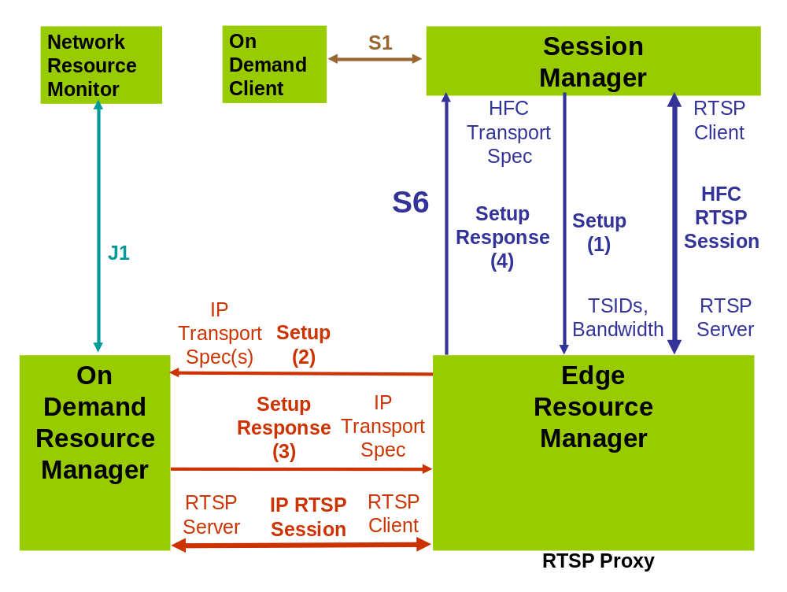

Figure 4: Interface S6 in the threaded architecture

